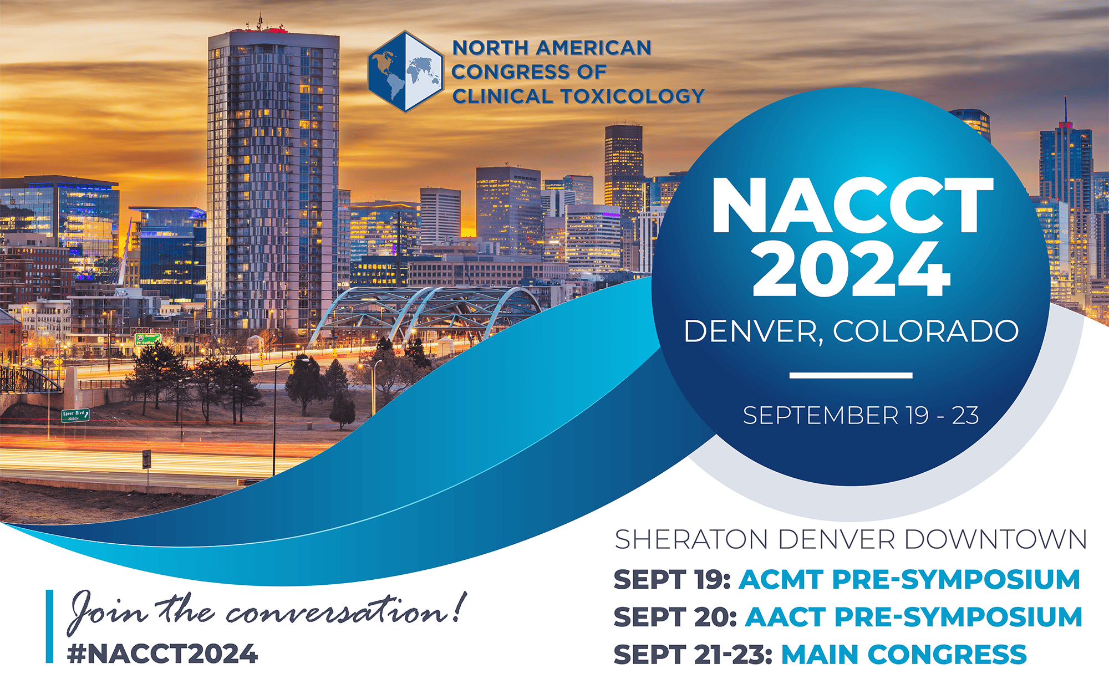

**Lightening Oral**

**Presenter Checklist**

**What is a Lightening Oral Presentation?**

A **Lightening Oral Presentation** is an abstract selected by the Convener or Program Committee to be presented in a symposium at NACCT 2024. Each lighting session is 30-minutes. Each lightening speaker receives 5 mins of presentation time and followed by 2 mins of Q&A. **Additionally**, there is a poster presentation ON THE SAME DAY as the oral presentation. The date and time of your presentation has already been sent to you.

[**If you don’t remember your presentation time, view the schedule here**](https://degnonassociatesinc.sharepoint.com/:x:/s/degnonallmembers/EXlsp6S_dHFPowYjgekS4eEBjjya2kOkLgml1YQCmiV5Pg?e=kb2vzC)

**Poster presentation times are below:**

* **Saturday 9/21 from 9:30am-10:30am** 
  + Set Up- Friday 9/20 from 1:00pm - 5:00pm
  + Required Display Time Saturday 9/21 from 9:00am - 4:00pm
  + Break Down - Saturday 9/21 from 4:00pm - 4:45pm
* **Sunday 9/22 from 11:00am-12:00pm**
  + Set Up - Saturday 9/21 from 5:00pm - 5:45pm
  + Required Display time Sunday 9/22 from 9:00 AM - 1:30 PM
  + Break Down - Sunday 9/22 from 4:00pm - 4:30pm
* **Monday 9/23 from 12:30pm-1:30pm**
  + Set Up - Sunday 9/22 from 5:00pm - 6:00pm
  + Required Display time Monday 9/23 from 9:00am - 1:30pm
  + Break Down - Monday 9/23 from 1:30am - 3:00pm

**Lightening Oral Presentation Presenters must register to attend NACCT 2024 to participate in the symposium!** [**Click here to register today**](https://clintox.app.neoncrm.com/np/clients/clintox/event.jsp?event=14&)**. *Important note: Abstracts are subject to withdraw if presenting author does not register.***

**How to Format Your Presentation: (recommended)**

* Include no more than 3-4 short slides (1 per minute)
* Summarize your slides in 5 minutes
* Allow for 2 minutes of questions from the audience
* All scientific presentations are 16x9, High Definition. Acceptable formats are PowerPoint or PDF.

**Audio-Visual Set-up for Oral Abstracts**

Oral abstracts take place in scheduled meeting rooms. The meeting rooms are equipped with a screen, laptop, wired mic and small podium.

**General Guidelines**:

* Hold microphone close to mouth when speaking so attendees can hear your presentation.
* One slide = One idea
* Do not use more than one slide per minute
* Limit the text on your slides – *focus on the main message*
* Use less than 20 words per slide
* Utilize clear visuals and graphics instead of text
* Limit abbreviations and unnecessary text
* Use bullet points instead of full sentences
* Make sure slides are clear and readable – double space your text
* Use clear fonts and contrasting colors
* Avoid the use of ALL CAPITAL letters or underlined text, as they are difficult to read
* Remember, your slide must be readable from the back of the session room
* Prevent using font sizes smaller than 18pt
* Cite your sources

**Questions?**

Please e-mail NACCT Staff with any questions at [NACCT@clintox.org](mailto:NACCT@clintox.org).

We look forward to seeing you in Denver!

Sincerely,

NACCT